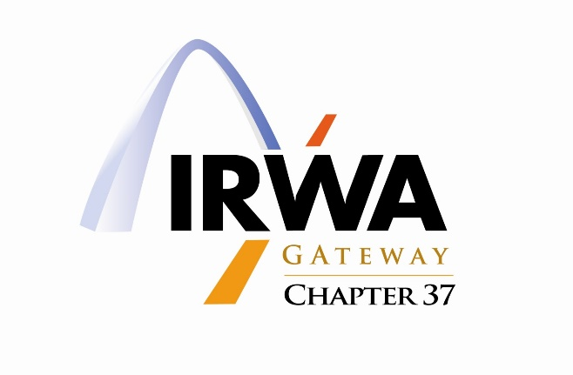
Executive Board Meeting Minutes – December 2, 2022

Meeting Location: Virtual meeting-via Teams

Meeting Date: December 2, 2022

Attendees: Chapter 37 Board Members and Committee Members
(Kristin Bauman, Bronte Fencel, LaToya Franklin, Tara Green, Kim Gross, Scott Gross, Vint Hoffeditz, Teresa McClure, Chris Scharth, Brendan Weiler)

The Executive Board meeting was called to order at 9:01 A.M. by Tara Green, President.

CHAPTER BUSINESS

- Lake Ozark Wrap Up
  - Please send any photos to Brendan Weiler to be uploaded to Ch. 37 website

- Membership Engagement and IRWA Incentives
  - Emails are being sent to members/employers to renew annual membership, please be on the watch for these

- Nominations for International Awards and Recognitions for IRWA Education Conference
  - Soft deadline is 12/31/22
  - Bronte Fencel is currently working on Chapter of the Year application for submittal
  - Brendan Weiler has completed Website of the Year application
  - There is an opportunity for Employer of Year for companies with more than 20 employees in ROW, please contact Teresa McClure for assistance with application completion

- Next Chapter Quarterly Meeting
  - Tentative date of Wednesday, January 25, 2023
  - In-person, working with Alex Sammett to secure Spire conference room
  - 11:30-1:30 Time slot
  - Speaker-Norm Willoughby, please submit email scenarios to Tara Green by 12/20 to provide to speaker

- Next IRWA Course
  - Next course will likely be a virtual course, hoping for more participation with this option
  - Tentative date of February 3rd
  - Course 600-Environmental Awareness (8-hour course)
  - Possible Course 209-Negotiating Effectively with a Diverse Clientele (16-hour course)-April 6-7
  - Possible Course 803-Eminent Domain Law Basics for ROW Professionals (16-hour course)- June 2023
  - Kristin Bauman will prepare a save the date communication for members to get opinions on upcoming courses

- Upcoming Quarterly Meetings
  - Please send Spring meetings ideas, speaker options to Tara Green
  - Beginning February 2023, nominations can start being received for board members
  - Nomination/Election Committee-Jody Harness, Teresa McClure, Brett Farner
  - In search of a large enough place for May 2023 meeting to book soon, most likely will not be at Fairmount City

- Bylaws
  - Approved by International
  - Motion to approve will be done during in-person meeting January 2023
  - Brendan Weiler will upload to Ch. 37 website as reference in meeting invite for January

- Open Discussion/Chairperson Updates
  - Declaration of Candidacy is due by 12/31/22 to IRWA, please make sure if you are wanting to be certified under the old or new education requirements that your paperwork is submitted
  - Corrected Treasury Approved by show of hands by Exec. Board

MOTION TO ADJOURN: Meeting adjourned at 9:42 A.M. by Tara Green, President, approved by Scott Gross and seconded by Brendan Weiler.

These minutes respectfully submitted by LaToya "Toy" Franklin, Secretary, IRWA Chapter 37.

