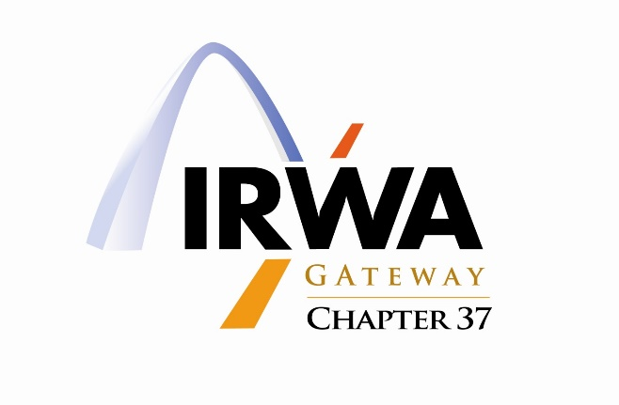
Meeting Minutes – November 17, 2022

Meeting Location: In-person (The Resort at the Lake of the Ozarks) and Virtual via Microsoft Teams

Meeting Date: November 17, 2022

Attendees: ___32 including members and guest in-person and virtual

The Chapter meeting was called to order at 12:16 P.M. by Tara Green, President.

CHAPTER 37 BUSINESS

- Welcome and Safety Message
- Tara Green, President presented the welcome message and Carrol McCracken presented the safety topic and handout on "Safety in the Right of Way World"

- Meeting Minutes from 11/7/2022
- Minutes submitted by LaToya "Toy" Franklin, Secretary

- Treasurer's Report
- Bank of America account to rollover to new Chase bank account
- Awaiting Scott Gross, Treasurer amended report

- Ongoing Chapter Business
- Currently 111 Members in Chapter 37, goal is 20% growth, continue to invite guest
- Member renewals due by 12-31-22, emails reminders being sent out
- Tara Green and Vint Hoffeditz to follow-up with IRWA for next level of incentives on members growth
- IRWA Course 603 being hosted November 18, 2022 at Lake of Ozark, continue to encourage class participation in-person and virtual
- Please contact Kim Gross, President Elect for assistance with credentialing
- Young Professional Chairs: Bronte Fencel & Max Turner have planned Escape Room & networking/socializing at Tucker's Shuckers for Course 603 on November 18, 2022
- Refer to Ch. 37 Website for new job postings

- New Chapter Business
Nominations for International Awards and Recognitions for IRWA Education Conference being accepted for the following awards/recognitions:

    - Chapter of the Year
    - YP of the Year
    - Website of the Year-Tara Green, President is nominating Ch. 37
    - Employer of the Year
      - Less than 20 employees in ROW department
      - More than 20 employees in ROW department
      - Government employer of the year
    - Newsletter of the Year

- Bylaws-recently approved by International on 11-2-2022, presented for vote at January 2023 in-person Chapter meeting
- Holiday Networking Celebration-Please contact Alex Brown for ideas, possible date late January
- Community Service Event-Hoyleton Youth & Family Services: all links on Ch. 37 website, all donations due by November 30th
- Region 3 Spring Forum held by Chapter 20 in St. Paul, Minnesota on March 26-28 or April 16-18
- Drawing for a free IRWA Course in 2023

- Open Discussion
- Region 3 is in search of a Secretary/Treasury
- Scholarship of $2500 "Leaders Light the Way", please use Carrol McCracken as a resource if interested in applying, January 15, 2023 deadline

MOTION TO ADJOURN: Meeting adjourned at 12:50 P.M. by Tara Green, President, approved by Mark Bushnell and seconded by Alex Brown.

These minutes respectfully submitted by LaToya "Toy" Franklin, Secretary, IRWA Chapter 37.

