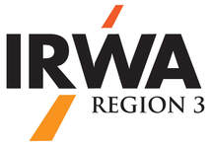

2025 Fall Forum – Hosted by Chapter 37

October 16, 2025 – St. Louis, MO

Fall Forum Registration Fee $75.00

Accommodations at a reduced block rate of $189.00/night (plus tax/fees) at

Hilton St. Louis at the Ballpark

[Hotel Registration Link](https://url.us.m.mimecastprotect.com/s/INxRC2krp6HVAnRmsnfZi5zzfe?domain=hilton.com/)

IRWA Couse 218 – Right of Way Acquisition for Electrical Transmission Projects

2 Day Course October 14 & 15 at Ameren HQ

$415 Member Rate, $575 Non-Member Rate

MORE DETAILS TO FOLLOW!!!